Vincent Nguyen

Dr. Mazidi

CS 4395.001

17 April 2023

Chatbot Report

System Description

* In my chatbot program, I used the OpenAI API. OpenAI helped respond to the user inputs. I used NER to determine the names of the users when they had input their names. I used web scrape to scrape two websites (one about the origins of basketball and the other about the origin of ice hockey) and stored them into two text file to use them as the input for OpenAI later. I also used regex to clean up the text files. I utilized term frequency, though I could not get OpenAI to output it. The user model is in the text file but I was not able to get OpenAI to use it.

Instructions to use it

* I used an IDE (Pycharm) to execute my chatbot code. Then, it gives me a local url, which you can click and it takes you to a chatbot mockup.

Sample Dialogue Interactions

* Below are the two ways I interacted with OpenAI that uses the web scraped websites to answer questions on the origin of ice hockey and the origin of basketball.

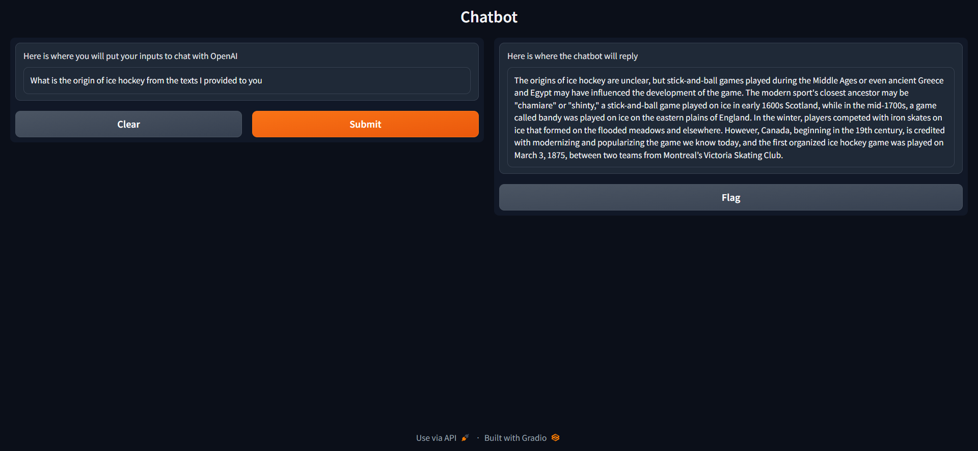

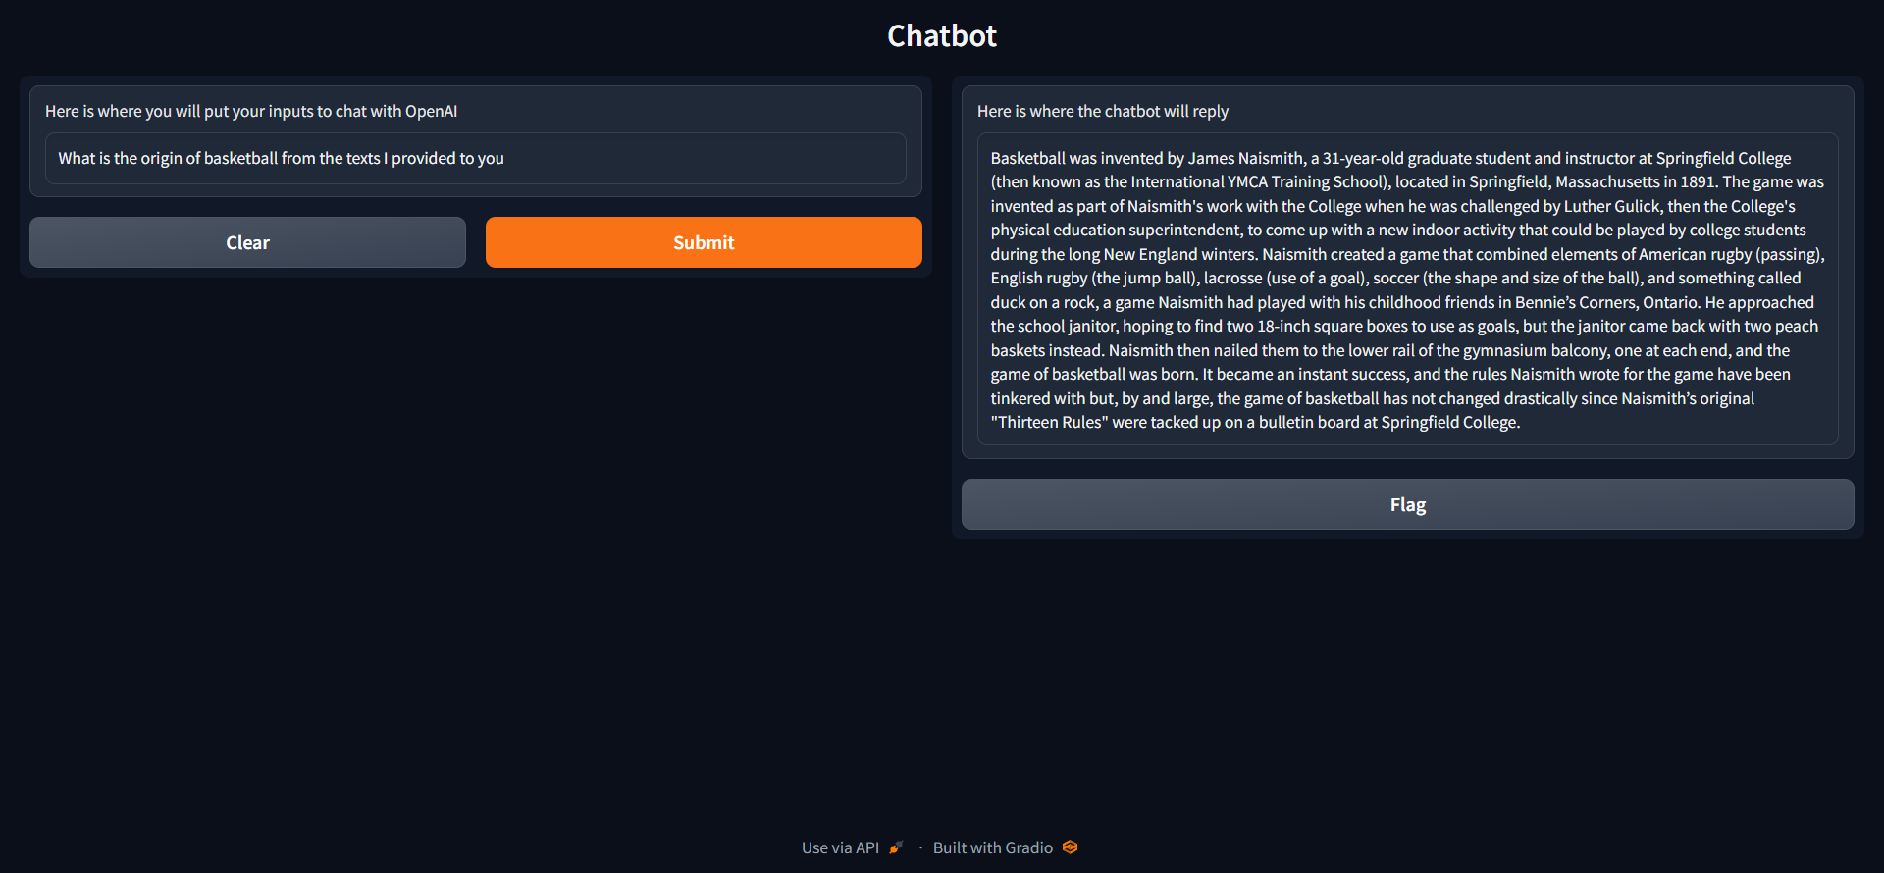

Appendix of Links Used

* There are two links that I hard coded into the program that we used to web scrape. Below is the MLA citation for it.

“Springfield College.” *Springfield College*, https://springfield.edu/where-basketball-was-invented-the-birthplace-of-basketball.

“Who Invented Hockey?” *History.com*, A&E Television Networks, https://www.history.com/news/who-invented-hockey-origins-canada.

Appendix of Sample User Models

* These are the sample user models I created. I stored the user models in the text file. While I was able to create new profiles for every new user, I was not able to get their likes, dislikes, and personal information from the dialogue they chatted with the chatbot into the text file.

Strengths and Weaknesses

* One strength this chatbot has is that it replies to the user’s input well. This is because of the utilization of the OpenAI API.
* There are some weaknesses in this chatbot program. First, it was not able to store likes, dislikes, and personal information of the user. Also, the chatbot was not able to use the term frequency and the user model.